Hasil Program

1. KomisiPegawaiTes.java

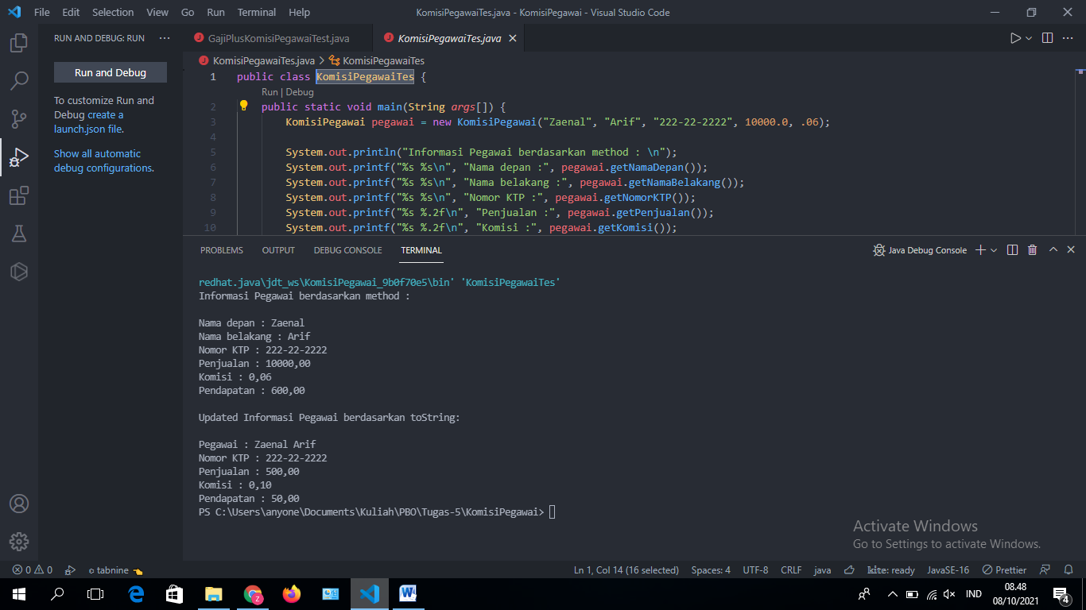

2. GajiPlusKomisiPegawaiTest.java

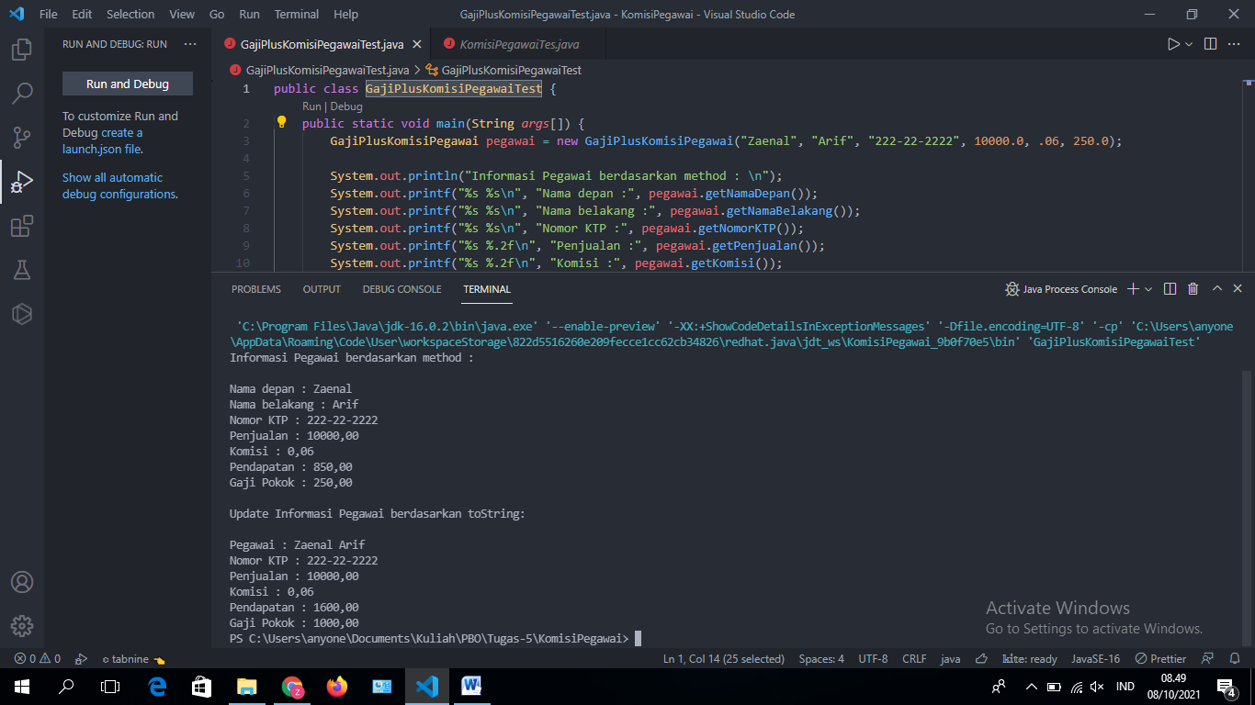

3. Inheritance/ PolimorphismTest.java

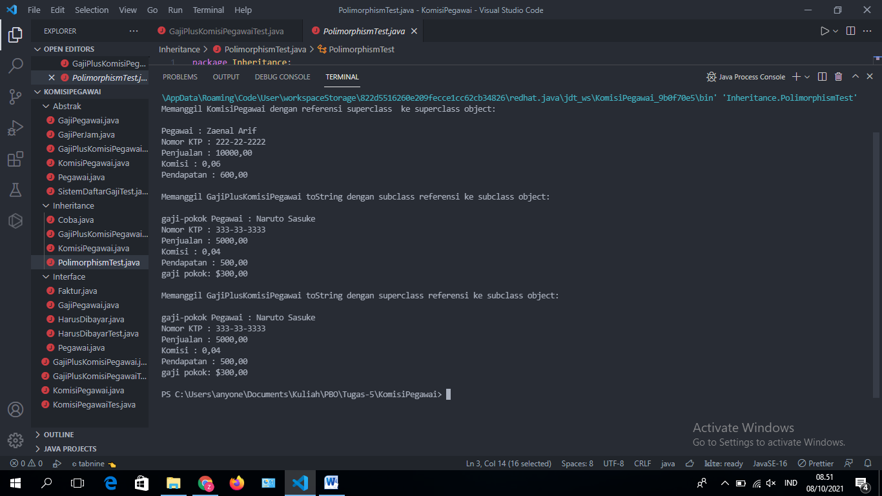

4. Abstrak/ SistemDaftarGajiTest.java

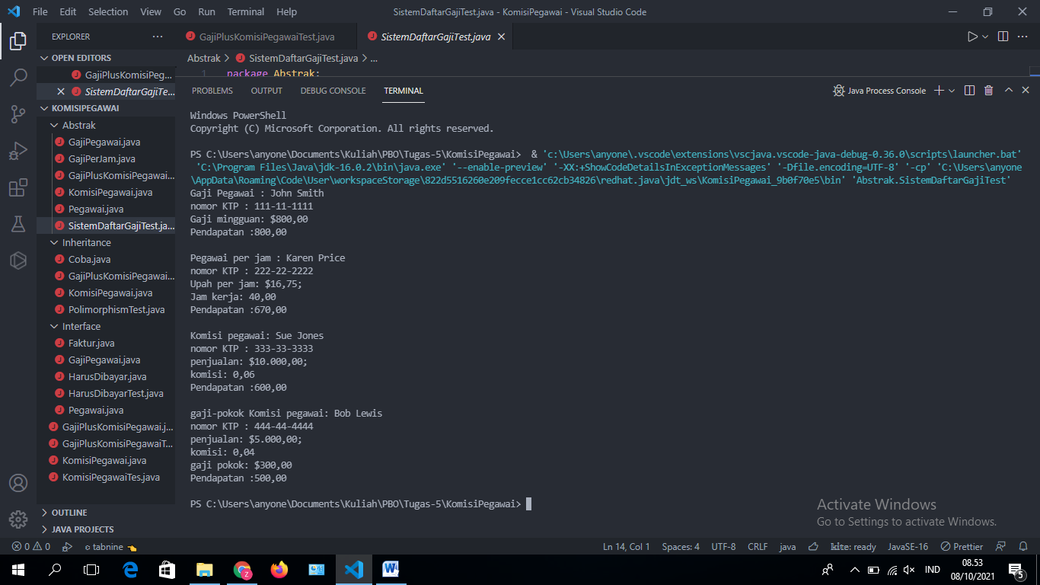

5. Interface/ HarusDibayarTest.java

